FARRINGTON HIGH SCHOOL
SUMMER BEGINNING HIGH SCHOOL ORCHESTRA
& JR. ORCHESTRA PROGRAM
Dr. Karen Miyamoto, Instructor
June 6-July 14, 2016
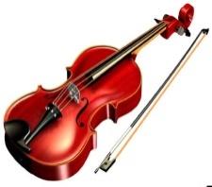
Who: Students in Grades 9-12 & 1-8 for the 2016-17 School Year
What: Beginning Orchestra; Learn to play a string instrument—Violin, Viola, Cello, or Bass; Instruments provided; No experience needed.
When: June 6-July 14, 2016; Mondays, Tuesdays, Wednesday Thursdays; Free Lunch Included; Registration Deadline May 25, 2016.
Where: Farrington High School Orchestra Room
Why: Play for enjoyment; Develop music skills, enjoy music, enjoy more of life; Meet new friends; Play lots of different kinds of music; Play in an Orchestra.
Requirements: $125 Registration Fee [Cash Only]; Purchase of the Orchestra Uniform ($22-$75); Regular Attendance.

FARRINGTON HIGH SCHOOL
SUMMER JR. ORCHESTRA PROGRAM
CONTRACT & REGISTRATION FORM

We read and understand the Farrington High School Jr. Orchestra Program Information. We agree to follow and abide by the rules, policies, and procedures [Registration Fee; Purchase of Uniform; Regular Attendance; All DOE School Rules Apply].

Student’s Name:_______________________________________School:_____________
First Last

Grade in 2016-17:__________________________

PROGRAM OF ENROLLMENT: Start Date—June 6, 2016; End Date—July 14, 2016 (Check all that apply)
FREE Lunch included with Registration. Daily from 10:00-10:35 A.M. (Children 12 and Under need to be accompanied by an adult to Lunch.)
____Farrington High School Beginning Orchestra Program (Grades 9-12) [M-TH 8:00-10:00 A.M.]
____Farrington High School Beginning Jr. Orchestra Program for (Grades 1-8) [M-TH 10:40-12:00]

PAYMENT:
____Enclosed is the nonrefundable payment of $125 for enrollment [Cash Only]. [Includes course materials, Instruction, Music, Instrument, and accessories.]

Total Amount Enclosed: $________[Cash Only]

Parent’s/Legal Guardian’s Signature/Date:

[Mail Forms and Payment to: Raden Nagamine, Summer School Director; Farrington High School; 1564 North King Street; Honolulu, HI 96817; (808) 305-5000; Registration Deadline May 25, 2016]
FARRINGTON HIGH SCHOOL ORCHESTRA
UNIFORM ORDER FORM 2016-17
(PLEASE SUBMIT THIS FORM WITH PAYMENT)
DUE WITH PAYMENT (Allow 4-6 Weeks for Delivery)
[Girls/Ladies may wear Muumuu or Blouse and Black Long Dress Slacks]

Girls muumuu Uniform: Floor length (must cover shoes). Lei neckline, puff sleeve, ruffle bottom muumuu; O28R; Color—Maroon Aloha Print (Purchase black covered dress shoes on your own—no sports shoes.)
Size | Girls  6 | Girls  7 | Girls  8 | Girls  10 | Girls  12 | Girls  Ladies Muumuu Style pictured below to the left. Girls Style to the right. (Not actual fabric.)  14
Price | 42.00 | 42.00 | 42.00 | 47.00 | 47.00 | 47.00

Size | Women’s Muumuu 1/2 | Women’s  Muumuu 3/4 | Women’s  Muumuu 5/6 | Women’s  Muumuu 7/8 | Women’s  Muumuu 9/10 | Women’s  Muumuu 11/12 | Women’s  Muumuu 13/14 | Women’s  Muumuu  15/16
Price | 75.00 | 75.00 | 75.00 | 75.00 | 75.00 | 75.00 | 75.00 | 75.00
Boys Uniform (Girls & Boys): Maroon Aloha Print Shirt (Purchase long, black dress pants on your own (no jeans); Purchase black dress shoes on your own (no sports shoes).
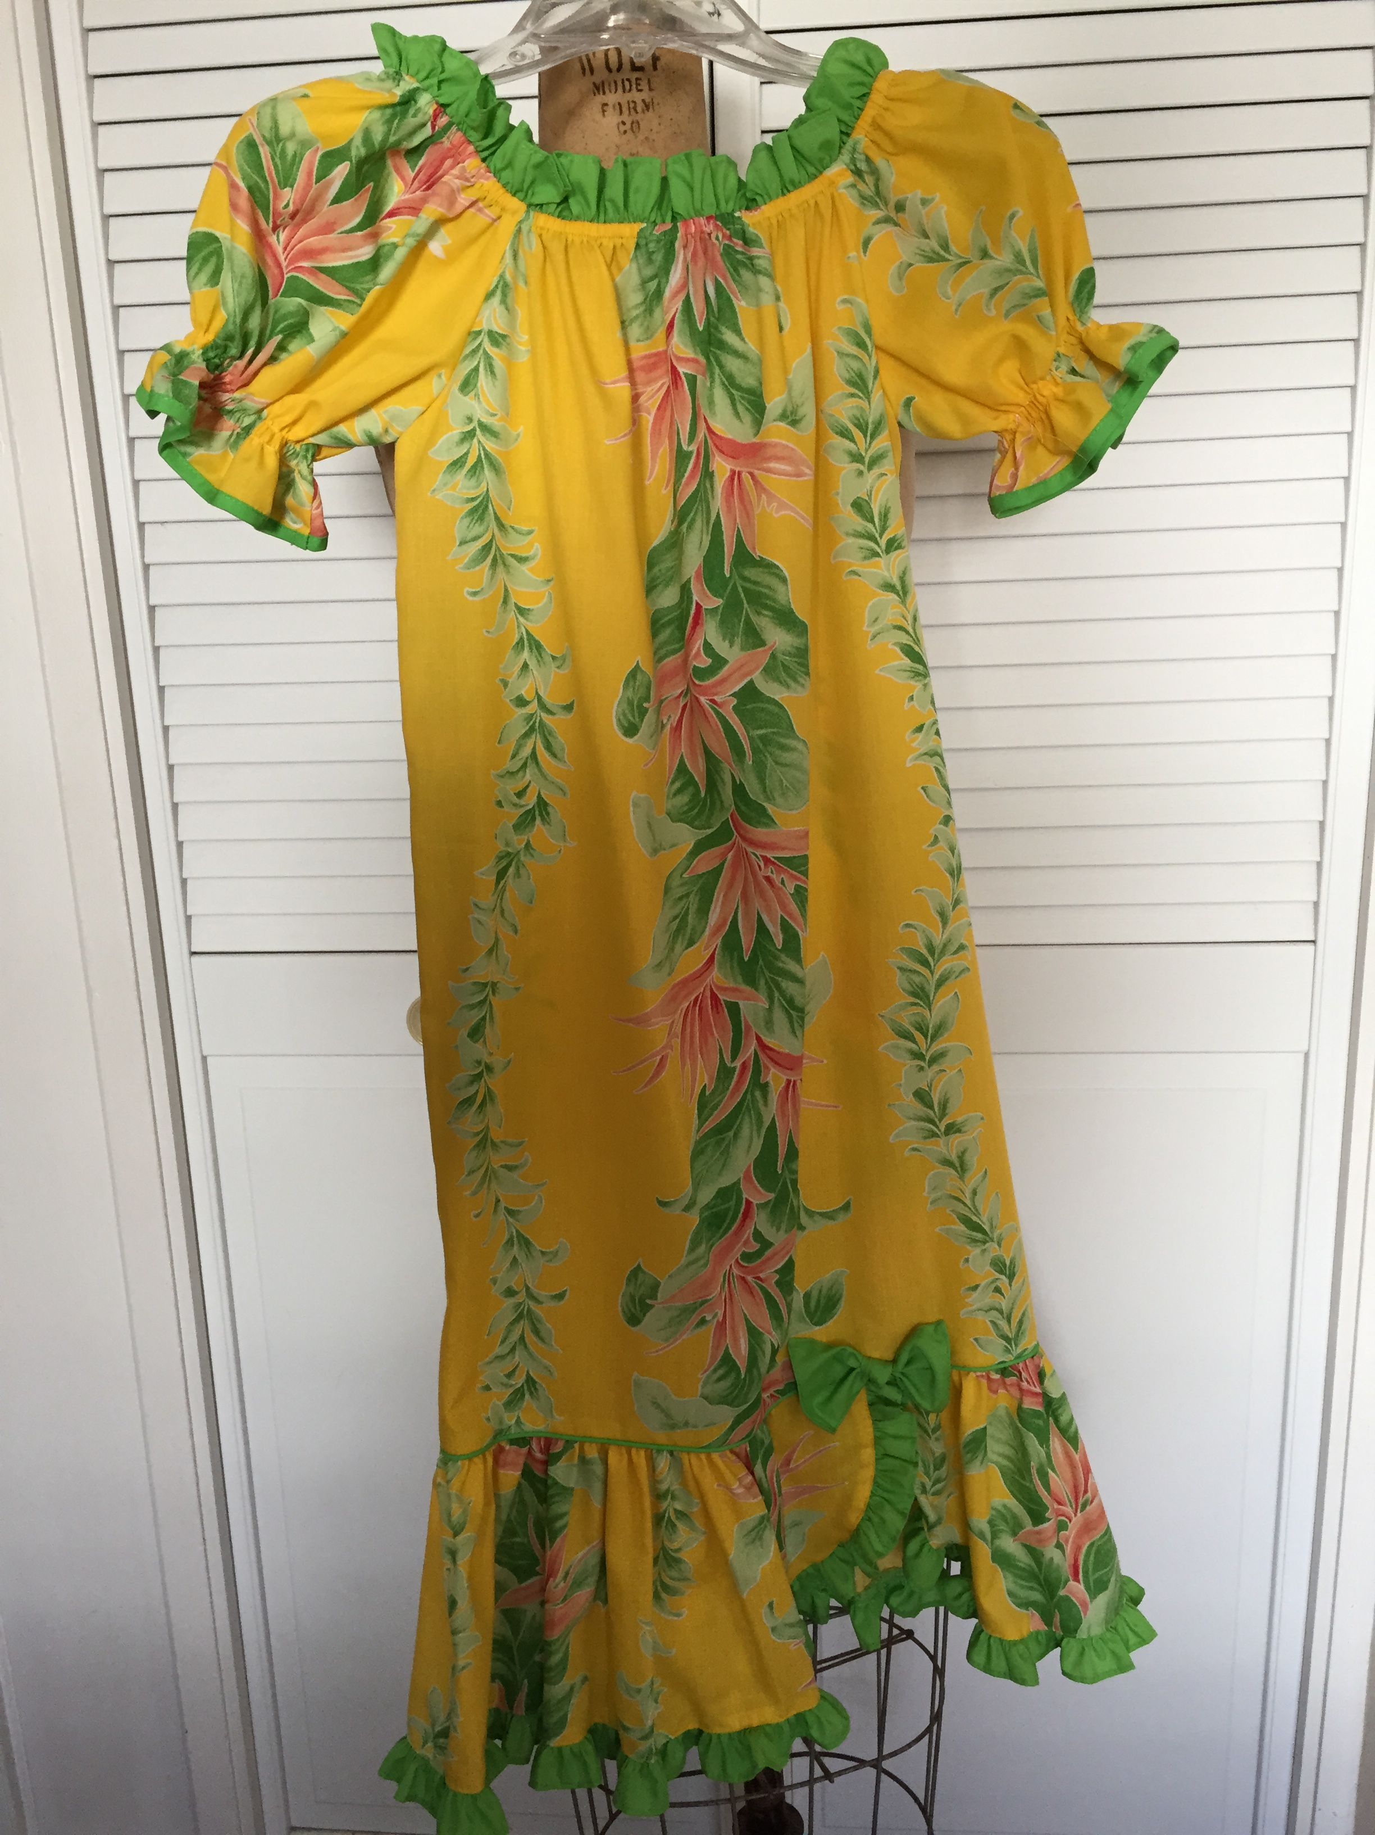
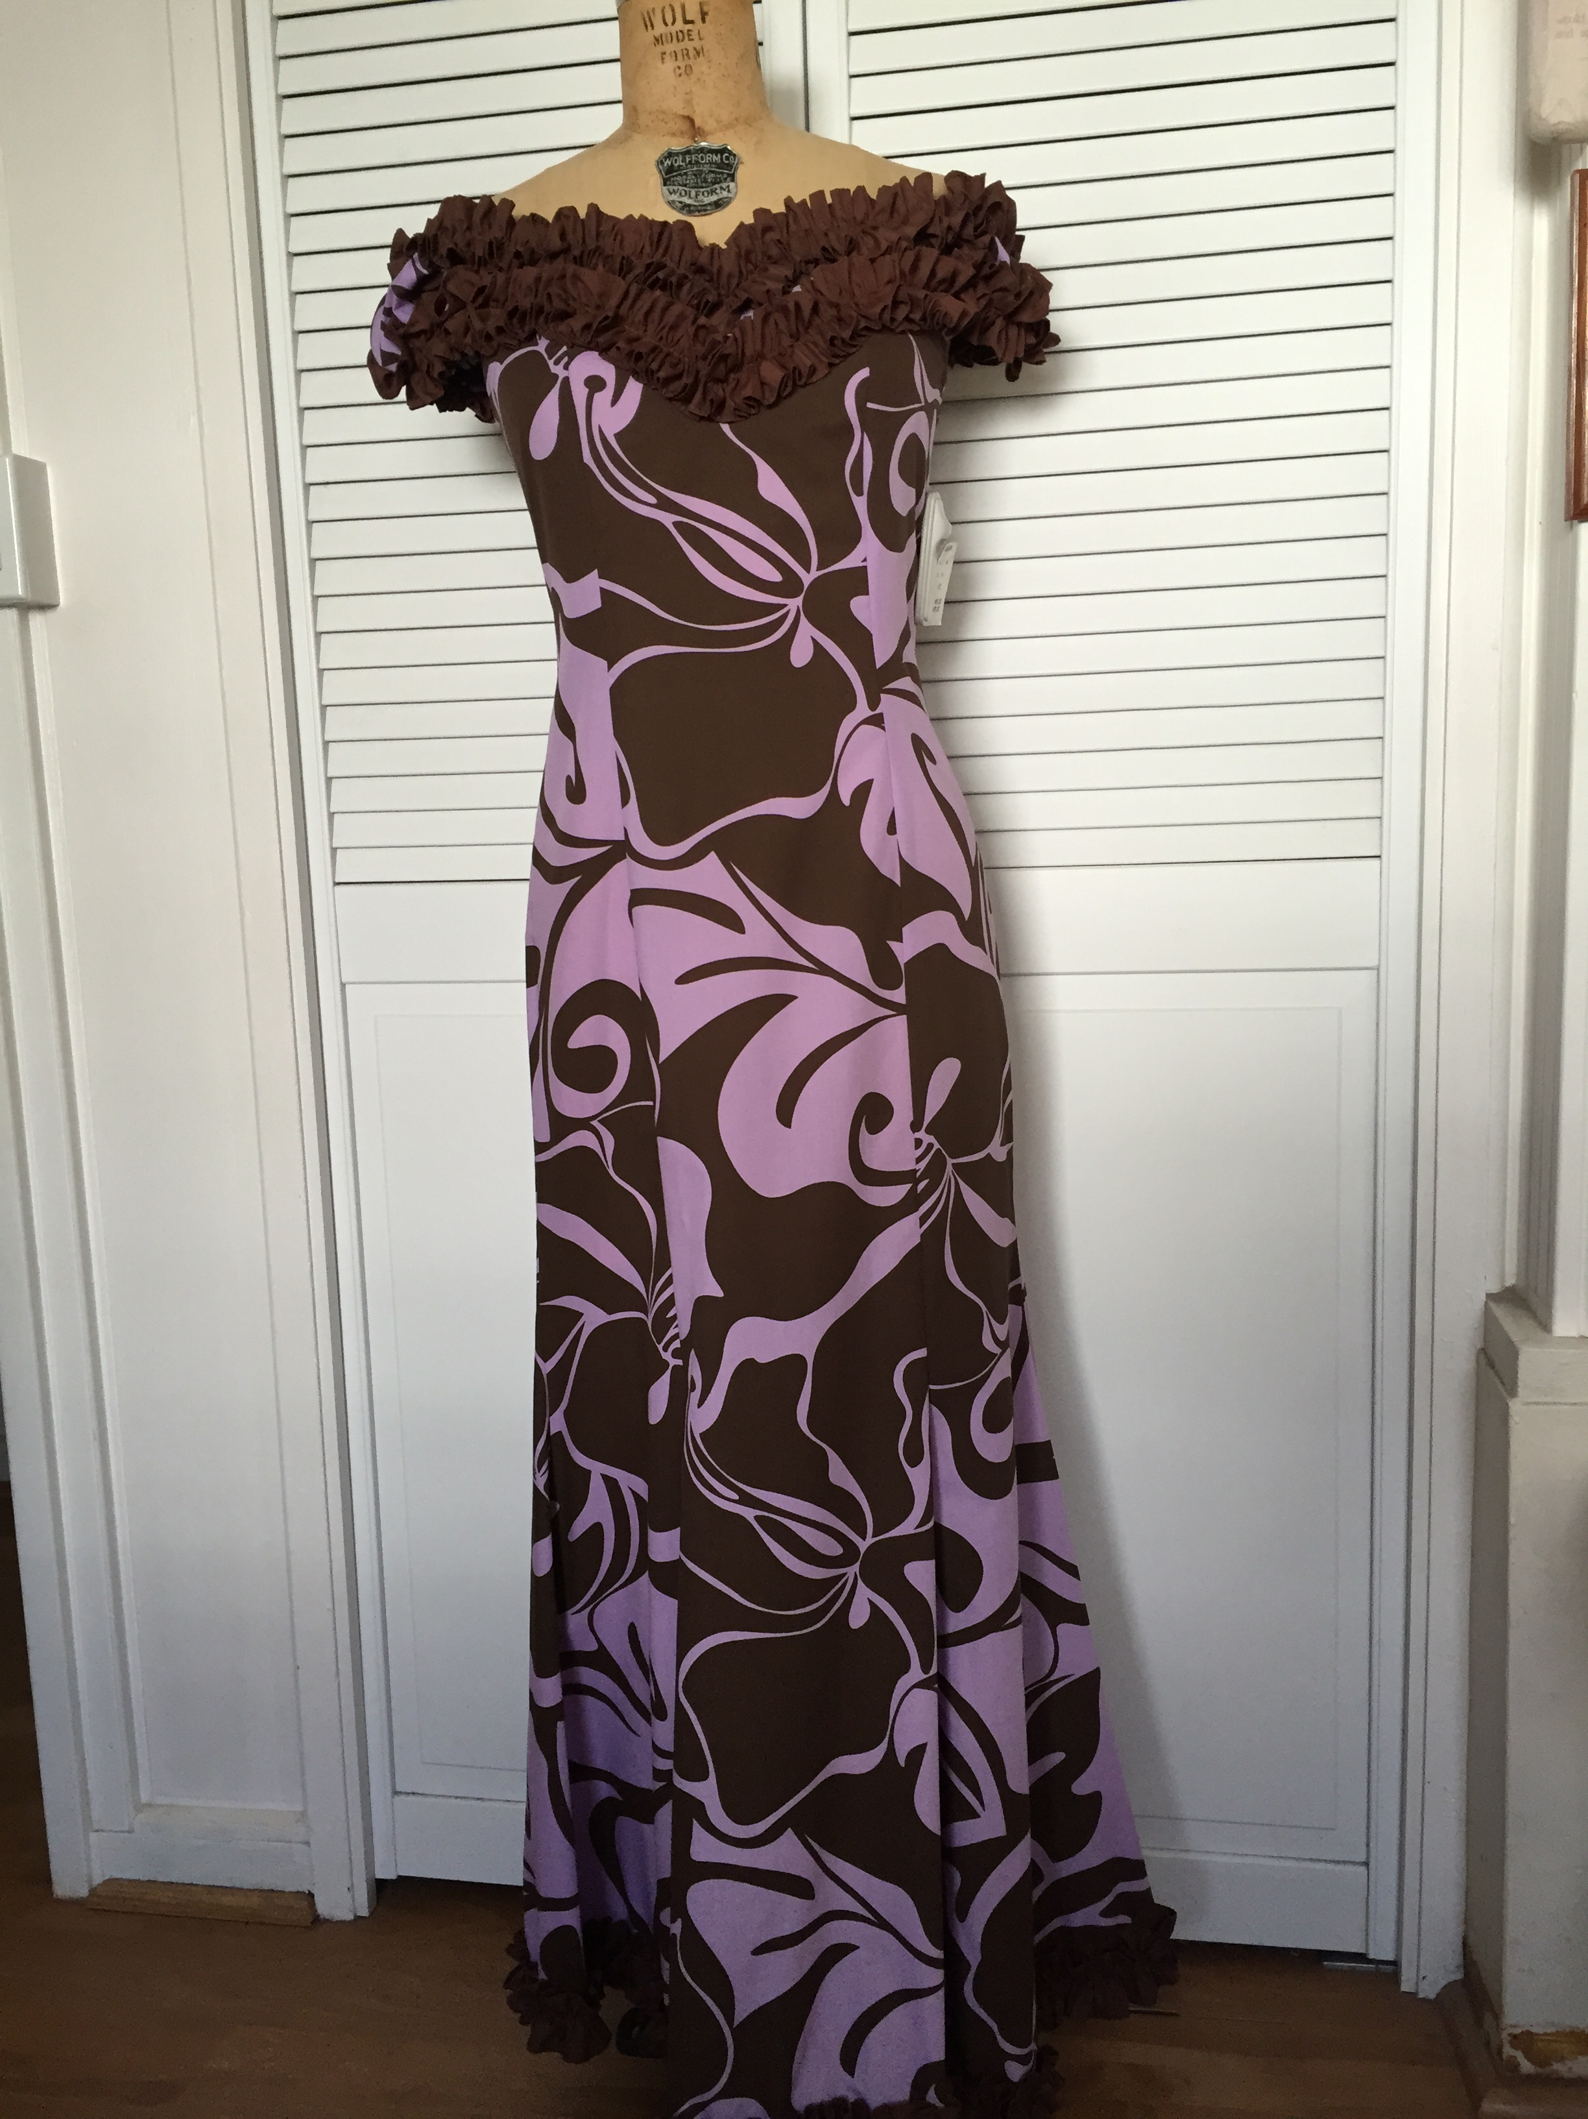
Size | Youth Shirt 10 | Youth Shirt 12 | Youth Shirt 14 | Youth Shirt 16
Price | 22.00 | 22.00 | 22.00 | 22.00

Women’s Blouse | XS | S | M | L | XL
Price | 37.00 | 37.00 | 37.00 | 37.00 | 37.00

Men’s | XS | S | M | L | XL | XXL | XXXL | XXXXL | XXXXXL
Price | 37.00 | 37.00 | 37.00 | 37.00 | 37.00 | 42.00 | 42.00 | 52.00 | 52.00
***[GIRLS AND BOYS MUST PURCHASE BLACK COVERED DRESS SHOES & BLACK LONG DRESS PANTS ON YOUR OWN]
------------------------------------------------------------------------------------------------------------
MUSIC PROGRAMS UNIFORM ORDER FORM 2016-17
PLEASE INCLUDE PAYMENT WITH ORDER (CASH ONLY); ALL SALES FINAL AND NONREFUNDABLE.

STUDENT’S NAME:___________________________________________________
First Last
GRADE:____________ HOMEROOM NUMBER:__________________
(INDICATE SIZE AND QUANTITY BELOW; SEE ABOVE PRICING; CIRCLE SIZE BELOW)
GIRLS MUUMUU: 6 7 8 10 12 14
Sample Sizes: Sample sizes available in the Farrington Office. Or at class on the first day.
LADIES MUUMUU: 1/2 3/4 5/6 7/8 9/10 11/12 13/14 15/16
LADIES BLOUSE: XS S M L XL
BOYS SHIRT: 10 12 14 16
MENS SHIRT: XS S M L XL XXL XXXL XXXXL
[***Ladies Sizes Provide Shoulder to Floor Measurement:___________]
TOTAL AMOUNT INCLUDED WITH ORDER: $__________

______________________________________________
Parent’s/Legal Guardian’s Signature/Date
The uniforms will be used for the End-Of-Summer Performance and for performances throughout the years as the programs continue. High School Concert Orchestra & Junior Orchestra will be offered after school during the school year.

