Family Education Training Center of Hawaii
Teen Internship in Sustainable Sciences 2015/16
@The University of Hawaii, Hale Tuahine (2727 Woodlawn Drive)
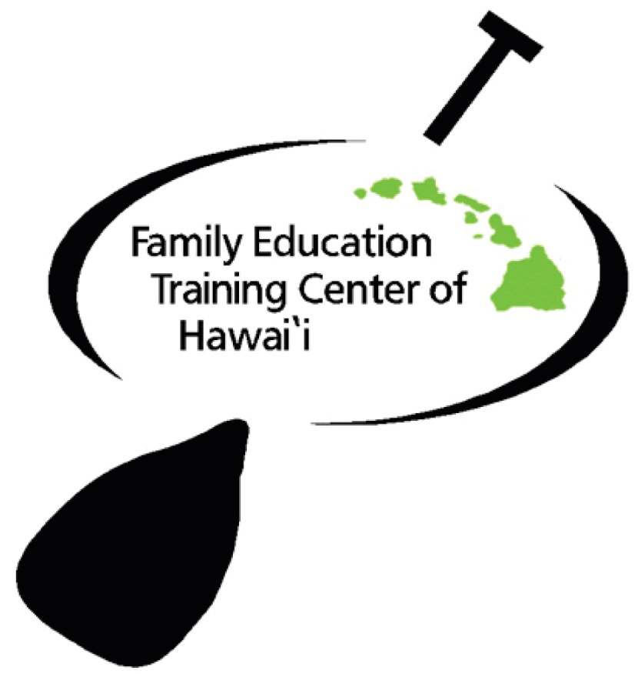

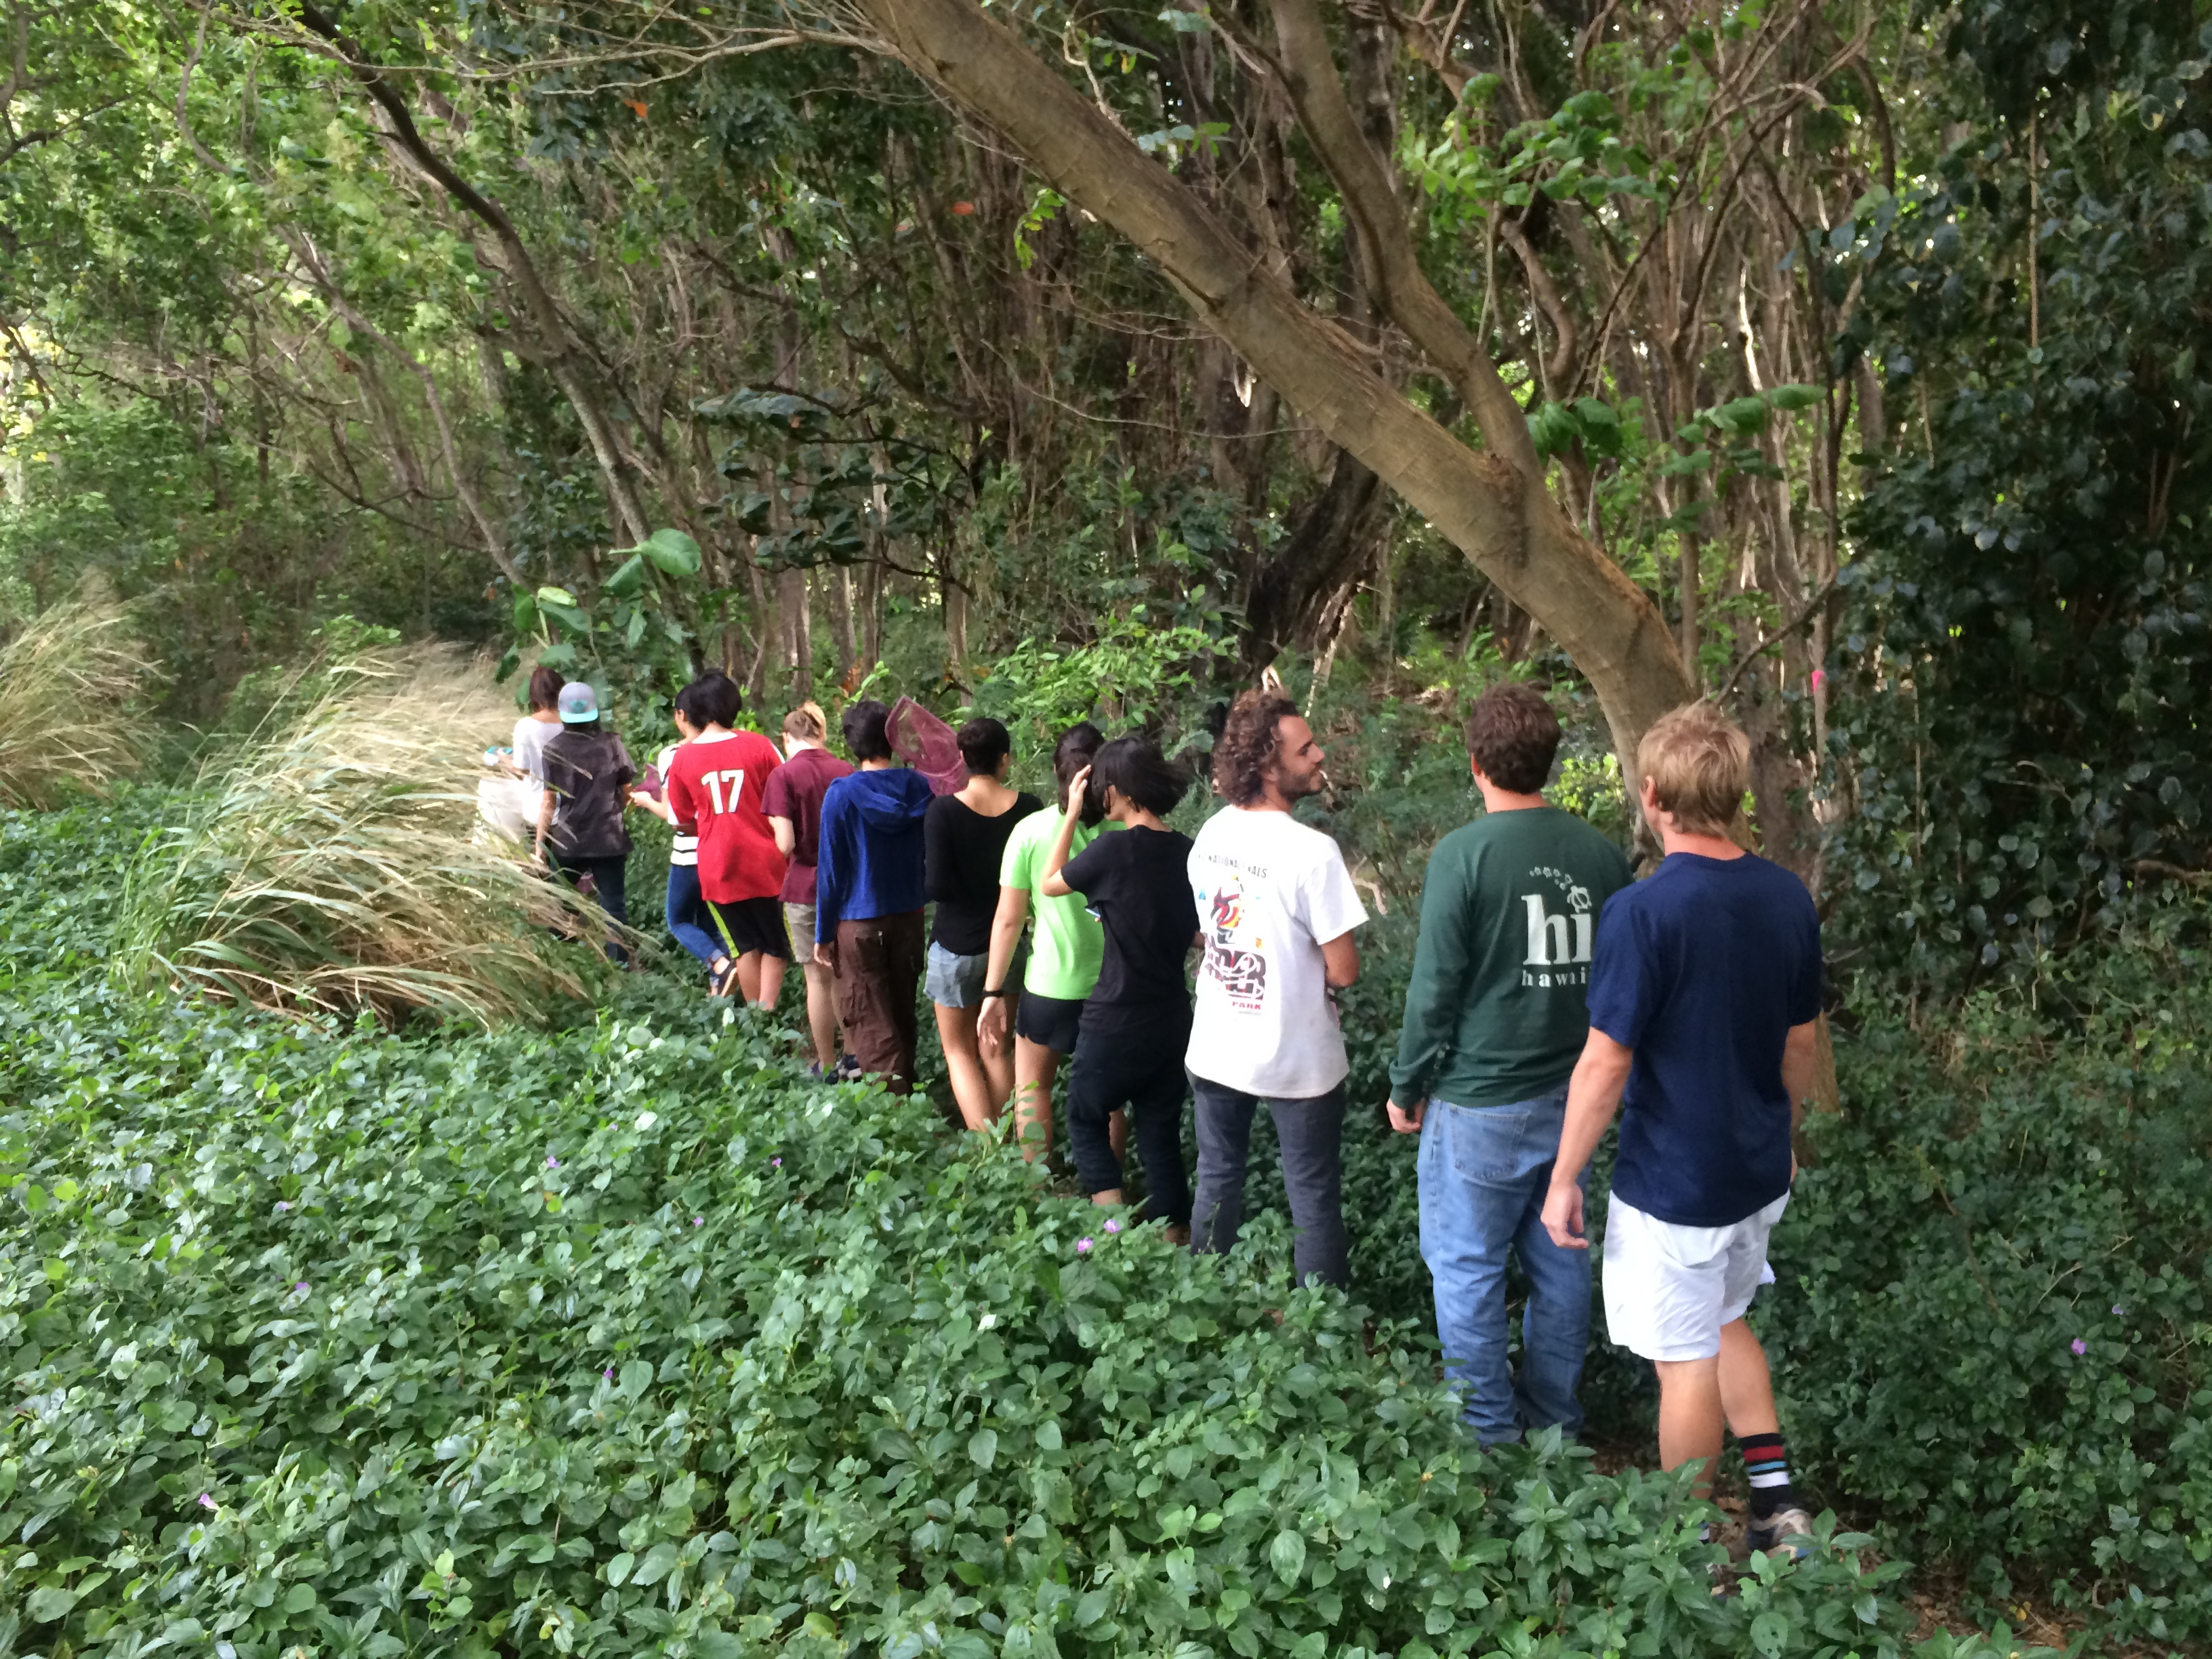
UH mentored science internship
Wednesday afternoons

About the Teen Internship Program in Sustainable Sciences
●●●
- Looking for a community-based internship?
- Need community service credit?
- In need of support and resources for your senior project and college entrance preparation?
We can provide these services and a great opportunity to strengthen your school’s Community Partnership with UH Manoa!
●●●

We invite High School Sophomores, Juniors and Seniors to join the Sustainable Science Internship program where you will work in small groups with University of Hawaii mentors to plan, build, care for, harvest and market your own sustainable, organic farm. You will be exposed to hands-on "best practice" farming methods, as well as the botany, biology, soil science and chemistry that explain the effectiveness of these methods. This knowledge will help prepare you for introductory college courses in the life sciences as well as in business. (Please see page 6 for the detailed units of the curriculum.)
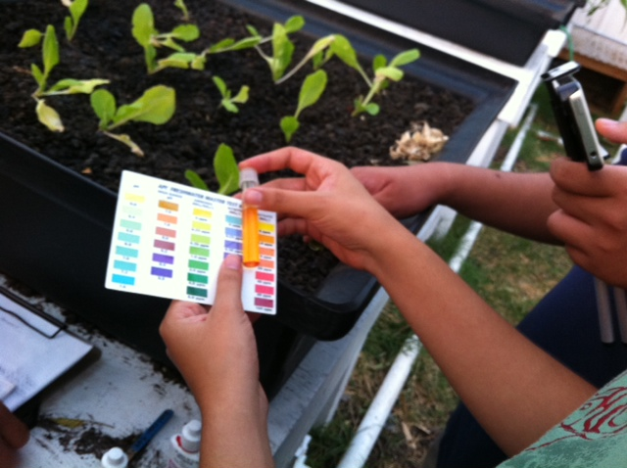
You will also become skilled at cooking vegetable-based meals following recipes from 10 different culinary regions of the world. Each week, your group will prepare one component of a dinner that we will all eat together.
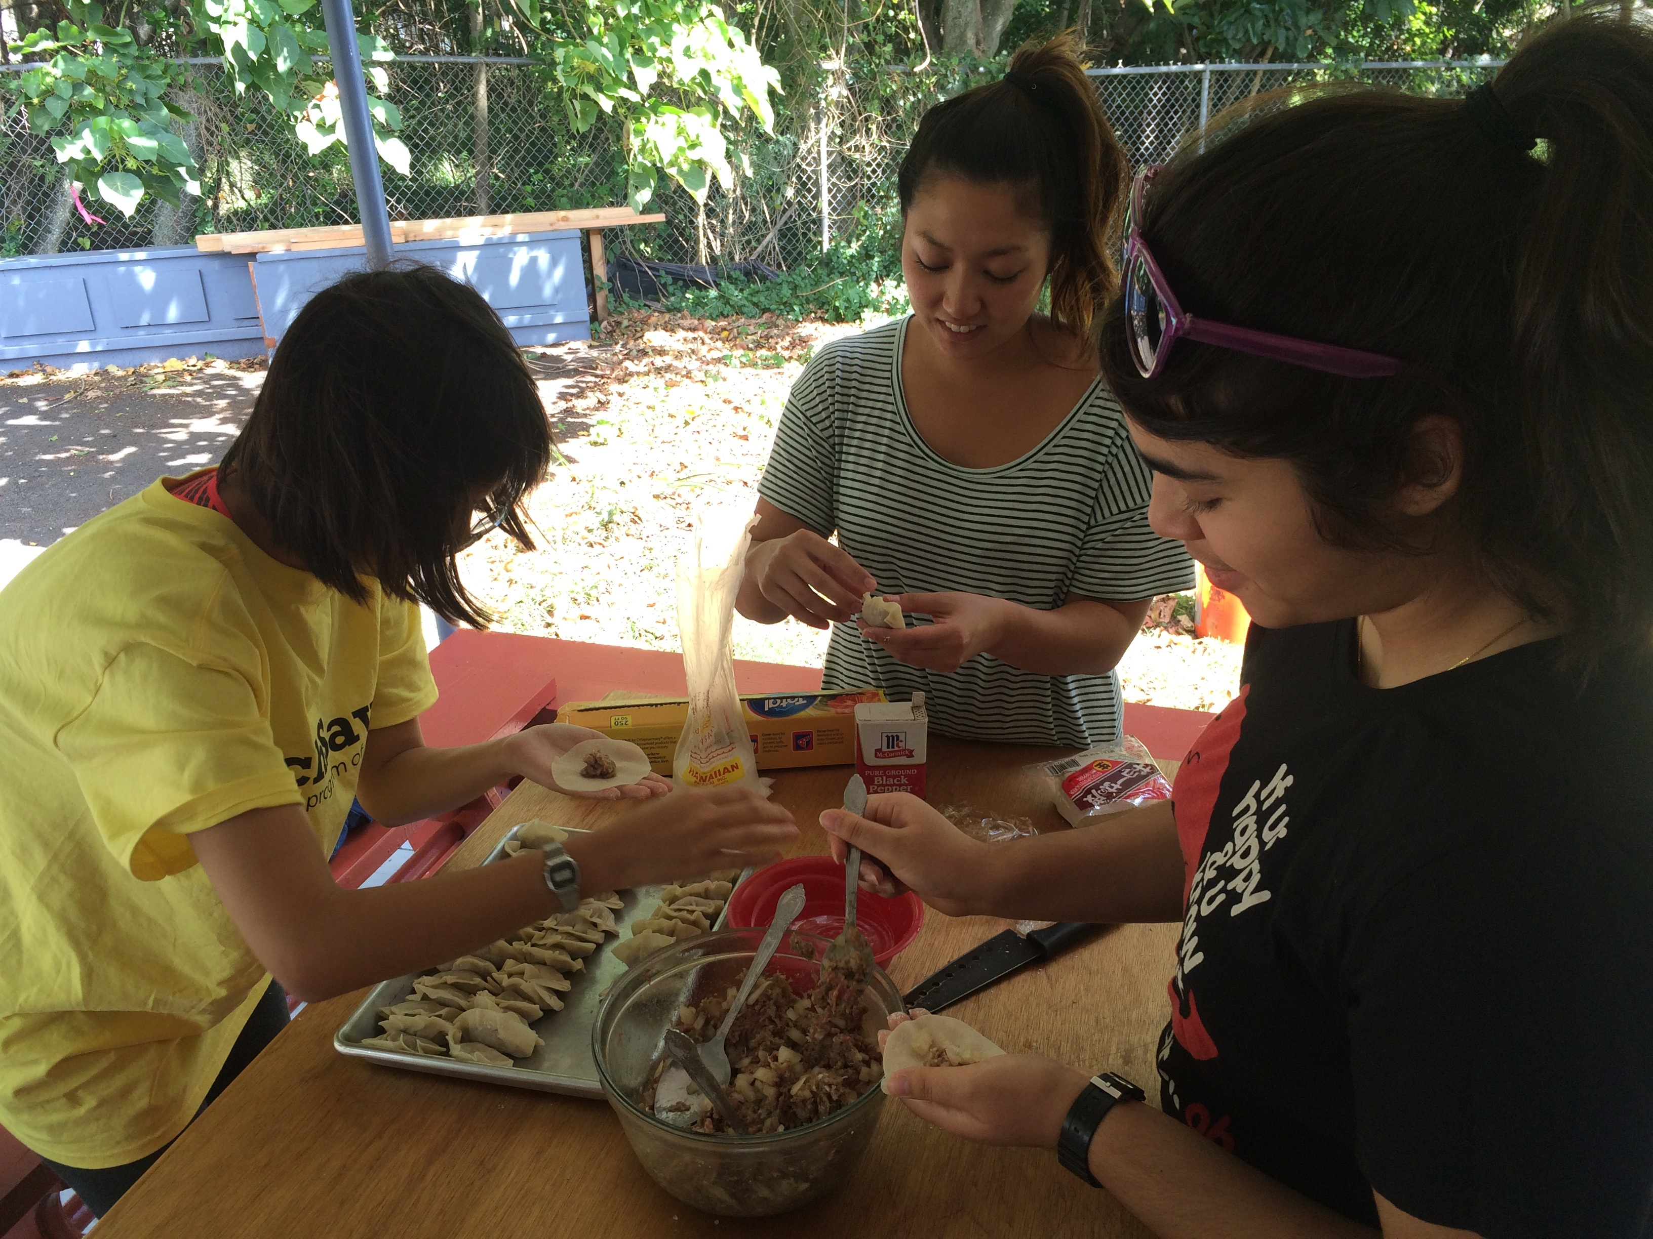
You will build your positive sense of self-identity in this safe, supportive environment where participants find they break through self-imposed limitations. Past participants stated they developed concern for others through teamwork and team-building and gained skills in: self-reflection and understanding; goal-clarification; respectful communication; active listening; conflict resolution; group organization; leadership; and how to belong in a group by participating in a variety of hands-on and adventure-learning activities.

The program utilizes a mindfulness approach. Mindfulness is a state of active attention to the present. Mindfulness involves observing our thoughts and feelings from a distance, without judging them good or bad. It encourages living in the moment and awakening to experience, rather than letting life pass one by. Proven benefits of mindfulness include: better focus & concentration; decreased stress & anxiety; enhanced health; increased self-awareness; skillful responses to difficult emotions; increased empathy and understanding of others; and development of skills for resolving conflict.
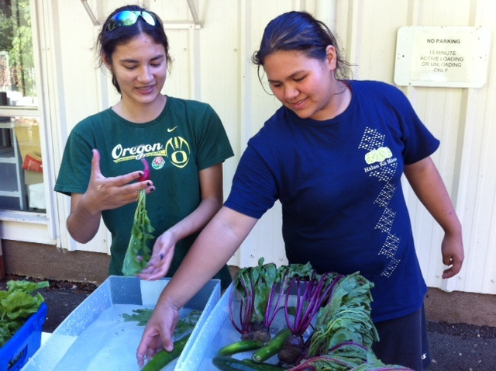
The internship program is limited to 15 participants (High School Sophomores, Juniors and Seniors) and is led by a team of experienced mentors with undergraduate and graduate degrees in the Sciences (Chemistry, Agriculture: Tropical Plant Science and Agroecology, Molecular Bioscience, Animal Science, Psychology and Education). The mentor to participant ratio is 1:3.
Program Schedule
The program will be held EVERY WEDNESDAY from 2:30 p.m. – 7:15 p.m. at Hale Tuahine (2727 Woodlawn Drive) right across the street from Long’s Drug Store at Manoa Marketplace. We will hold an Open House on Wednesday, September 16, at 2:30 p.m.
Dates of the session:
- September 16, 2015 (*Open House)
- September 23, 2015
- September 30, 2015
- October 7, 2015
- October 14, 2015
- October 21, 2015
- October 28, 2015
- November 4, 2015 (**NO session on November 11: Veterans Day)
- November 18, 2015
- November 25, 2015
11) December 2, 2015
***INTERNS MUST WEAR CLOSED SHOES & CASUAL CLOTHES!
****The second semester of the internship program starts on Wednesday, January 20, 2015, from 2:30 p.m. – 7:15 p.m.
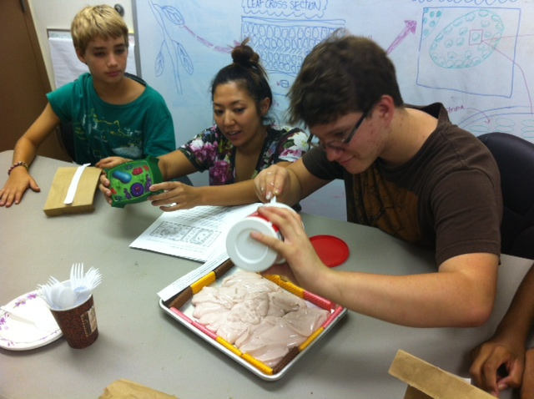
Registration and Payment
To register:
CALL (956-2248) or EMAIL (FetchOahu@gmail.com) TO RESERVE A SPACE. Inquiry is also welcome.
A FETCH staff member will contact you to confirm your registration. The parents of teen participants will be asked to complete the application form once the space is reserved.

Tuition:
$75 per teen per semester (11 sessions: September 16 – December 2, 2015)
*Dinner included: Students will prepare dinner during each session.
Payment method will be specified at the time of your registration confirmation. Payment must be received by September 23, 2015.

Testimonials: Read what past parents say about our internship program

“Through FETCH internship, my child learned how to problem solve and work well with a team, improved her communication skills and understanding of scientific principles particularly botany.”
-Lahela

“The FETCH program helped my daughter develop a better sense of self, a skill that hadn’t been acknowledged in her particular school setting. Also it was great for her to connect with and learn from the UH students and graduates.”
-Aunty Ku’u

“After the program, my child now teaches me scientific processes
behind growing and watering when we are out in the garden.”
-Jennifer

“My child developed knowledge of agricultural practices and gardening skills. We feel privileged to be a part of this organization, the skills and services she gained will be a great addition to her college applications.”
-Tracey

“The program instilled a sense of community togetherness in my boys. They also learned cooking skills and are more willing to help with dinner at home.”
-Tami

Detailed list of units of the science curriculum:
The curriculum is comprised of 8 units covered throughout the fall and spring semesters. The specific instructional units are listed below.
Unit | Topic
1 | CSA Farming & Human Nutritional Needs
 | Agri-business: visioning, setting objectives, planning, marketing, accounting, resource management, team-work, leadership, building the physical infrastructure
 | Organic eating for nutrition; field farming methods
 | Process of planning and planting crops, trees
2 | Preparing the Fields
 | Introduction to soil
 | Soil texture and structure; soil pH
 | Soil Amendment
 | Clearing, aerating, shaping grow beds
3 | Planning and Planting
 | Botany for farmers
 | Selecting crops, mapping the fields
 | Plant propagation and protecting plants
4 | The Role of Water in Plant Growth
 | The structure and properties of water
 | How plants take in and use water
 | Irrigation and designing gardens to conserve water
5 | Composting
 | Introduction to composting and various methods: aerobic and vermicasting
 | The decomposition process
 | Construction a composting system
6 | Plant Nutrient Requirements
 | Essential plant nutrients; nutrient uptake by plants
 | Signs of nutrient deficiencies; methods of replenishing nutrients in the soil
7 | Growing in Water
 | Why and how to grow plants in water: properties of water, why plants need water
 | Nutrient requirements of plants grown in water
 | Building a hydroponics/aquaponics system
 | Maintenance of an aquaponics system: water quality, data collection, feeding schedule
8 | Integrated Pest Management
 | Identifying insect pests in Hawaii; how to prevent and control insect pests: the CTAHR integrated pest management system
 | Organic methods of controlling pests
 | Identifying and preventing plant diseases
About FETCH
Organization and contact information:
The Family Education Training Center of Hawaii (FETCH) is a University of Hawaii-based affiliate of the Family Education Centers of Hawaii, a non-profit, 501 (c) (3), charitable organization. FETCH coordinates volunteer professionals and service-learning university students to provide services to families and youth here in Hawaii. FETCH is also sponsored by the State Department of Health (Alcohol and Drug Abuse Division) as well as the United States Department of Agriculture (National Institute of Food and Agriculture). We provide two programs during the Fall and Spring Semester: 1) the Sustainable Families Friday program in Family Strengthening (which includes a parenting class and social skills training for younger family members), and 2) theTeen Internship in Sustainable Sciences program on Wednesdays.

Family Education Training Center of Hawaii
Office: Energy House (on UH Manoa campus)
2020 East West Road
Honolulu, HI 96822
Phone: (808) 956-2248
Email: FetchOahu@gmail.com
Please visit our website: efetch.org

