FETCH Summer Workshop
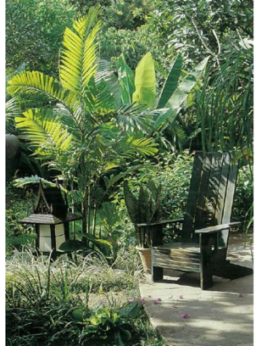
“Edible Garden Landscaping: Culture and Art”
Five weeks: May 30-July 1, 2016
Mon-Fri, 9:00 a.m.-2:00 p.m., including a group-prepared lunch
The Energy House, 2020 East West Road, UHM campus
Openings available: 12 slots for teens and adults, ages 13 and older
Instructors: 6

In this project-based workshop, participants learn some of the
cultural practices, art styles, gardening methods, and culinary
traditions practiced in 5 different regions of the world.

Participants work together in teams to design, build and add
décor to a small, regional garden, each week, following this schedule:
Week 1. Southeast Asia
Week 2. Pacific Island cultures (Hawaiian Ahupua’a garden)
Week 3. India
Week 4. West Africa
Week 5. South America

On the evening of June 24, participants will hold an “art and garden” event at the Energy House, displaying their drawings, sculptures, garden designs, and gardens to guests from a national conference held at the University of Hawaii.

On the final weekend of the program: July 1 and July 2, youth and their families may be able to participate in an optional (free of cost) campout, with guided outdoor activities, at Camp Erdman (depending on available funding).

Each week, youth will work in two teams to: produce art, design and build a small garden, and construct garden features, such as a trellis, bench and pots. They will cook lunches, using recipes and produce from that region of the world. During one week a team will be the gardeners and builders (designing, putting in the garden, and building a culturally-styled bench, trellis and pots for the garden), the next week they will be the artisans, (developing graphic art and sculptures for the garden). This way, youth gain hands-on experience in all aspects of edible garden development.

Each teen will be expected to complete weekly art, garden design and gardening projects. S/he will be expected to complete one, final graphics project and one final garden sculpture, that will be displayed in a capstone art event on June 24th. S/he will participate in team building of a trellis, bench, and/or clay pots for each regional garden, as well as prepping and planting out those gardens.

Sample Monday schedule of Art, Design and Garden Activities for that week’s region:
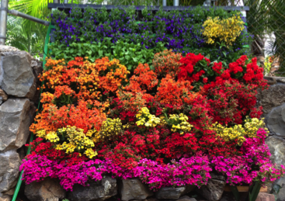
Mon, 5/30 | 9-9:15 | 9:15-11:00 | 11:00-12:00 | 12:00-1:45 | 1:45-2:00
Team 1: 6 participants with 2 instructors | Whole Group:  Lecture: South-east Asia culture & Whole group Planning meeting | Whole Group:  Lecture and hands-on activities:  (Dr. Kaufman) | Whole group Cooking from South East Asia and lunch  2 cooking instructors, | Whole group: Graphic Art & culture in South East Asia | Whole group  Summary  Meeting  (For the remaining 4 days of the week, participants will work in teams to apply the principles they learned on Monday to design the garden, add garden structures/décor; cook from that region and
Team 2: 6 participants with 2 instructors | “ | Garden design, structures & gardening in South East Asia | “ |  | produce garden art related to that region of the world.
Cost to participants: $200 for 5 weeks (25 days)=$8/day and covers food and art supplies
Participants must be able to walk safely on uneven terrain.
Instructors:
- Andrew Kaufman (PhD, Botany; Professor, Landscape Design, UHM) will teach
a planning workshop every Monday to guide the design of that week’s garden
- Matthew Kirkpatrick, (BA, Art & Art Education; 2 years experience teaching
magnet HS art) will teach Graphic arts and sculpture in relation to world region gardens.
- Adam Baker (Professional Furniture Woodworker) (MS, MBBE, CTAHR) Designing and building garden structures
- Kaya Terem, (BS, Chemistry; 4 years experience managing Energy House
Garden and Farm and teaching) will teach Garden layout, gardening and carpentry.
- Lehua Wall, (BS, Plant Science; Masters student in Animal Science; 2 years
teaching experience) will teach garden layout, gardening, carpentry
- Mary Martini (PhD., Psychologist, Director, FETCH, Professor UHM) will teach cooking, garden design, carpentry.
- Ana Vejar will assist in the cooking and art classes.

